**20.Design TM using simulator to perform subtraction of aaa-aa**

**AIM:**To design TM using simulator to perform subtraction of aaa-aa

**TRANSITION DIAGRAM:**

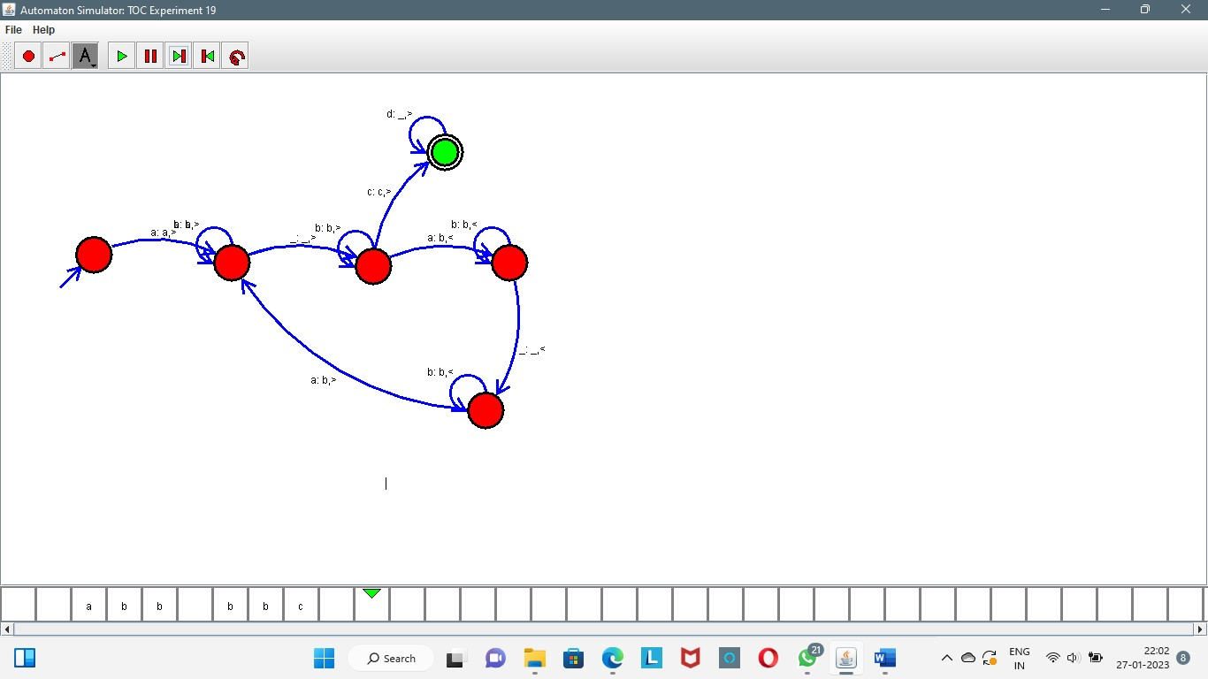

**RESULT:** The TM is designed & performed subtraction by using a simulator